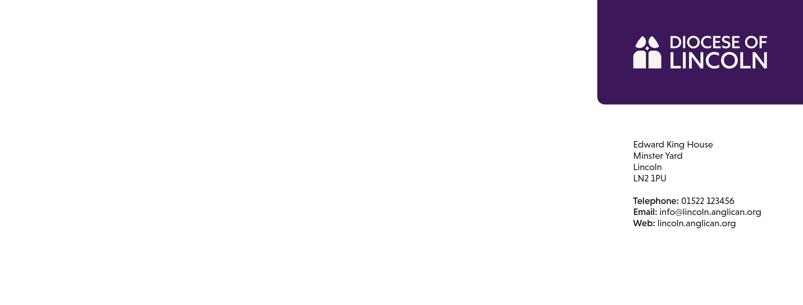

**Sharing in Prayer**

***January 2025***

|  |  |
| --- | --- |
| Wednesday 1st  The naming and Circumcision of Jesus  ***Animal Care\**** | **Grimsby and Haverstoe LMP**  **Partnership Dean and Rural Dean: The Revd Julie Donn**  **Lay Chairs: Mrs Kate Hutchinson and Ms Ruth Brewin**  *The Diocese of Kwoi – The Church of Nigeria (Anglican Communion)* |
| Thursday 2nd  Basil the Great and Gregory of Nazianzus, Bishops, Teachers of the Faith, 379 and 389  ***Armed Forces*** | **Church Schools in the Grimsby and Haverstoe LMP:**  East Ravendale, Humberston, North Cotes, Stallingborough  Ulceby St Nicholas, Cleethorpes St Peter’s, Wootton St Andrew’s, Grimsby Lisle Marsden and Immingham Canon Peter Hall  *The Diocese of Kyoto – The Nippon Sei Ko Kai* |
| Friday 3rd  ***Charity sector*** | **The Abbey Group of Parishes**  *The Diocese of Kyushu – The Nippon Sei Ko Kai* |
| Saturday 4th  ***Commerce & Retail*** | **Brocklesby Park, Croxton and North Worlds**  *The Diocese of Lafia – The Church of Nigeria (Anglican Communion)* |
| Sunday 5th  ***Construction Industry*** | **KEEP FREE**  *The Church in Wales* |
| Monday 6th  **The Epiphany**  ***Energy industry*** | **Immingham – The Revd Julie Donn**  *The Diocese of Lagos – The Church of Nigeria (Anglican Communion)* |
| Tuesday 7th  ***Farming*** | **Cleethorpes St Aidan**  TTCT Steering Group  *The Diocese of Lagos Mainland – The Church of Nigeria (Anglican Communion)* |
| Wednesday 8th  ***Finance*** | **Great Grimsby St Mary and St James**  *The Diocese of Lagos West – The Church of Nigeria (Anglican Communion)* |
| Thursday 9th  ***Fire Services*** | **Great & Little Coates with Bradley**  Clergy Housing Committee  *The Diocese of Lahore – The Church of Pakistan (United)* |
| Friday 10th  William Laud, Archbishop of Canterbury, 1645  ***Fishing industry*** | **Cleethorpes**  *The Diocese of Lainya – Province of the Episcopal Church of South Sudan* |
| Saturday 11th  Mary Slessor, Missionary in West Africa, 1915  ***Healthcare Services*** | **Grimbsy St Augustine**    *The Diocese on the Lake – The Church of Nigeria (Anglican Communion)* |
| Sunday 12th  Aelred of Hexham, Abbot of Rievaulx, 1167  ***Highways*** | **KEEP FREE**  *The Church of the Province of West Africa* |
| Monday 13th  Hilary, Bishop of Poitiers, Teacher of the Faith, 367  ***Horticulture*** | **Scartho St Giles with St Mathew – The Revd Dr Sheena Cleaton**  *The Diocese of Lango – The Church of the Province of Uganda* |
| Tuesday 14th  ***Hospices*** | **Humberston**  SDF Programme Board  *The Diocese of West Lango – The Church of the Province of Uganda* |
| Wednesday 15th  ***Hospitality*** | **Holton le Clay, Tetney and North Cotes – The Revd Jenny West**  *The Diocese of Langtang – The Church of Nigeria (Anglican Communion)* |
| Thursday 16th  ***Judiciary & Legal Services*** | **The Wolds Gateway Group – The Revd Christine Goldsmith and The Revd Mark Hutson**  Search and Nominations Committee  *The Diocese of Lebombo – Igreja Anglicana de Mocambique e Angola* |
| Friday 17th  Antony of Egypt, Hermit, Abbot, 356  ***Leisure and Sports Activities*** | **The Waltham Group – The Revd Pauline Cummins**  *The Diocese of Leeds – The Church of England* |
| Saturday 18th  Week of Prayer for Christian Unity  Amy Carmichael, Founder of the Dohnavur Fellowship, Spiritual Writer, 1951  ***Lincolnshire Community and Voluntary Service (LCVS)*** | **The Rt Revd Stephen Conway – Bishop of Lincoln**  *The Diocese of Leicester – The Church of England* |
| Sunday 19th  Week of Prayer for Christian Unity  Wulfstan, Bishop of Worcester, 1905  ***Local Authorities*** | **KEEP FREE**  *The Church in the Province of the West Indies* |
| Monday 20th  Week of Prayer for Christian Unity  Richard Rolle of Hampole, Spiritual Writer, 1349  ***MPs and Local Councillors (District & Parish)*** | **The Rt Revd Dr David Court – Bishop of Grimsby**  *The Diocese of Lesotho – The Anglican Church of Southern Africa* |
| Tuesday 21st  Week of Prayer for Christian Unity  Agnes, Child Martyr at Rome, 304  ***Musicians and those in the Arts*** | **The Rt Revd Dr Nicholas Chamberlain – Bishop of Grantham**  Finance Committee  *The Diocese of Lexington – The Episcopal Church* |
| Wednesday 22nd  Week of Prayer for Christian Unity  Vincent of Saragossa, Deacon, first Martyr of Spain, 304  ***Nature Conservation*** | **The Revd Nick Nawrockyi – Senior Chaplain to the Bishop of Lincoln**  *The Diocese of Liberia – The Church of the Province of West Africa* |
| Thursday 23rd  Week of Prayer for Christian Unity  ***Police and Fire Services*** | **Georgie Kirchen – Executive Assistant in the Bishops’ Office**  Boston AMPC  *The Diocese of Lichfield – The Church of England* |
| Friday 24th  Week of Prayer for Christian Unity  Francis de Sales, Bishop of Geneva, Teacher of the Faith 1622  ***Press/media*** | **Hayley Belcher – Executive Assistant in the Bishops’ Office**  *The Diocese of Lincoln – The Church of England* |
| Saturday 25th  Week of Prayer for Christian Unity  The Conversion of Paul  ***Prisons*** | **Alice Winslade – Administrative Assistant in the Bishop’s Office**  *The Diocese of Litoral Ecuador – The Episcopal Church* |
| Sunday 26th  Timothy and Titus, Companions of Paul  ***Social Services*** | **KEEP FREE**  *The Episcopal / Anglican Province of Alexandria* |
| Monday 27th  ***Tourism*** | **The Revd Kathy Colwell – Officer for Retired Clergy**  *The Diocese of Liverpool – The Church of England* |
| Tuesday 28th  Thomas Aquinas, Priest, Philosopher, Teacher of the Faith, 1274  ***Universities and Colleges*** | **The Revd Jeff Parr – Officer for Voluntary Clergy**  Diocesan Advisory Committee  *The Diocese of Liwolo – Province of the Episcopal Church of South Sudan* |
| Wednesday 29th  ***Young Peoples Uniformed Organisations*** | **Mrs Stephanie Green – Bishop’s Visitor**  Lincoln AMPC  *The Diocese of Llandaff – The Church in Wales* |
| Thursday 30th  Charles, King and Martyr, 1649  ***Youth and Children’s work*** | **The Bishop’s Office**  Children, Youth and Families Panel  *Missionary Area of Lodwar – The Anglican Church of Kenya* |
| Friday 31st  John Bosco, Priest, Founder of the Salesian Teaching Order, 1888 | Bishops Council of Diocesan Trustees Residential  *The Diocese of Lokoja – The Church of Nigeria (Anglican Communion)* |

***The items in Green type are sectors of Lincolnshire life. Each sector will receive a notification that they are being prayed for – please pray for the sector in general and any specific organisations close to you***

Sharing in Prayer – Queries relating to this prayer diary may be directed by email to collegeofsthugh@lincoln.anglican.org

Copies of Furthering Holiness – The Diocesan Supplement to Common Worship, commemorating the saints of the Diocese of Lincoln – are available upon request.